# Segment 6

#Segment 6: Broader Understanding of Data

#Classify thriller movies based on average ratings into different categories.

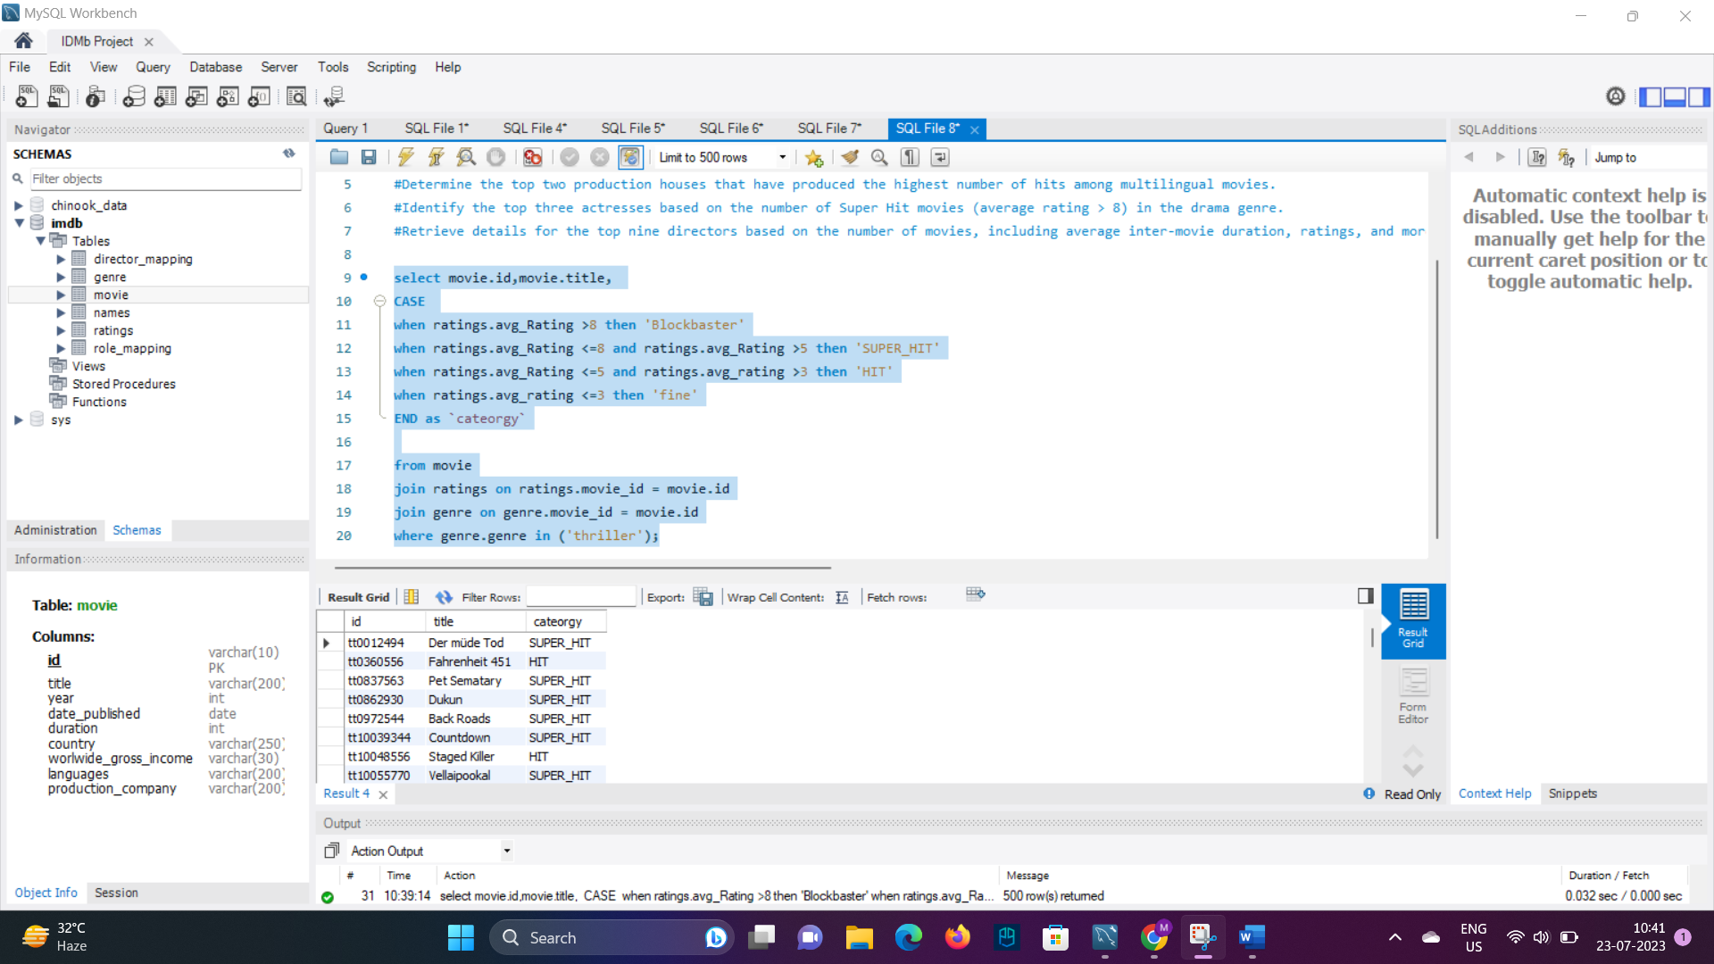

#analyse the genre-wise running total and moving average of the average movie duration.

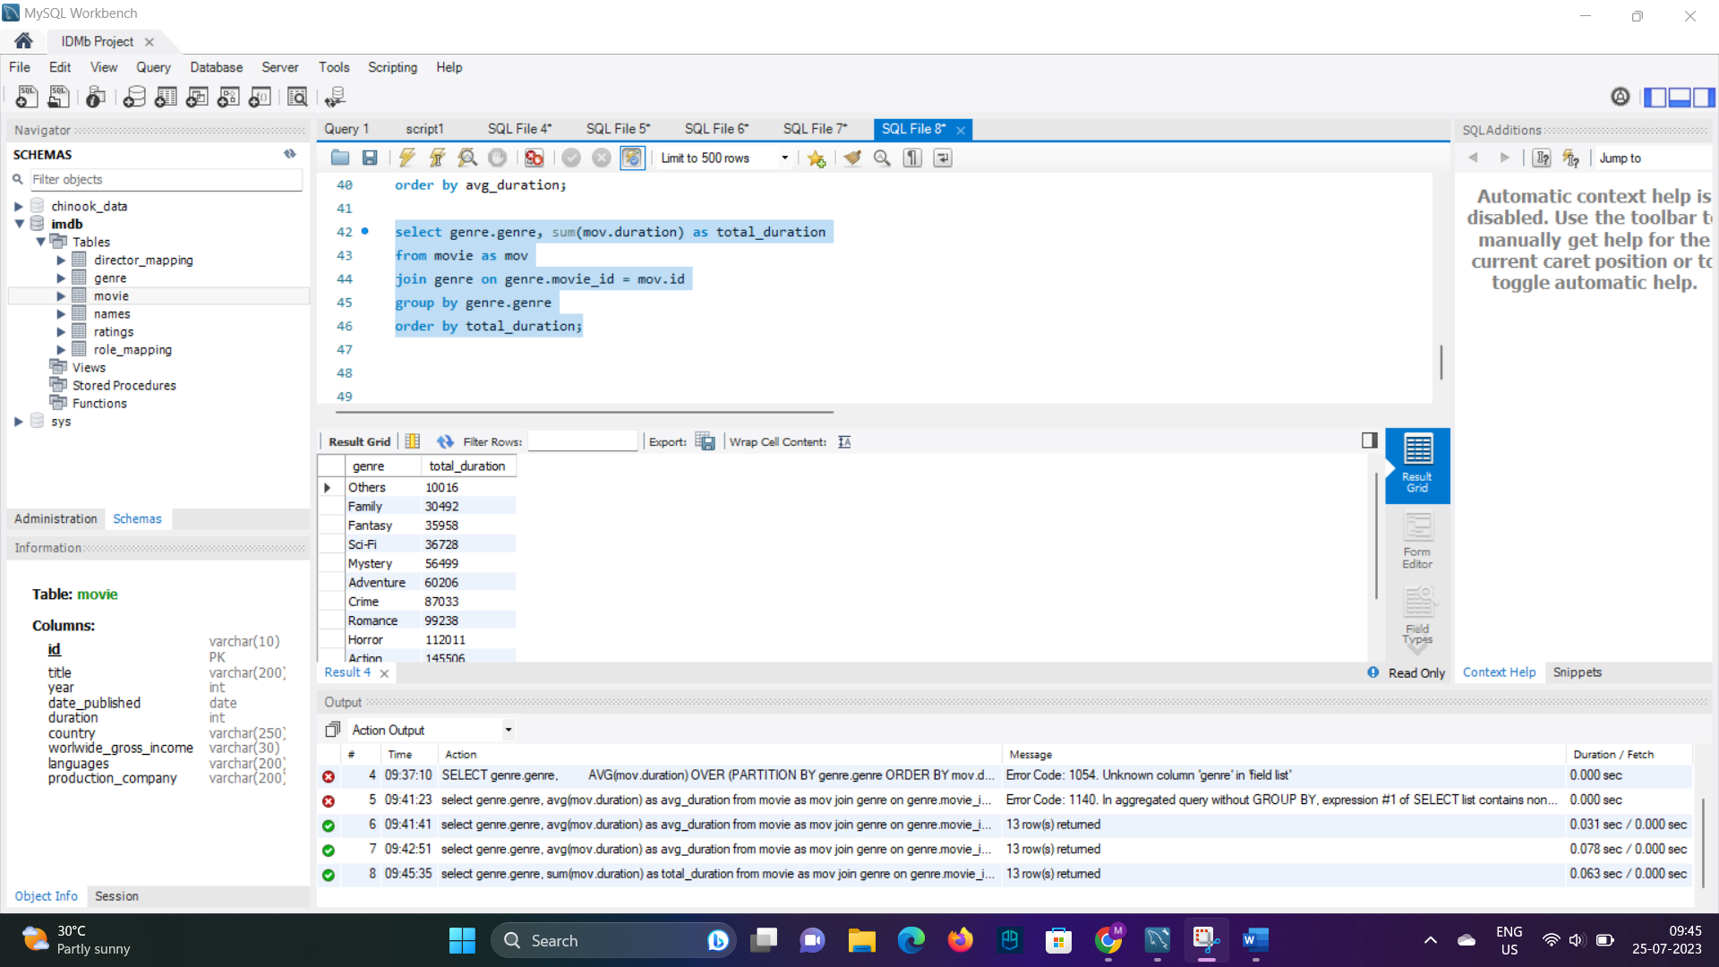

#Identify the five highest-grossing movies of each year that belong to the top three genres.

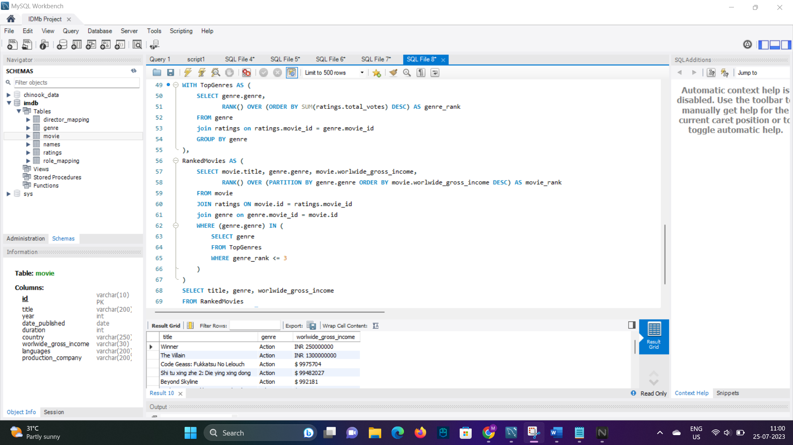

#Determine the top two production houses that have produced the highest number of hits among multilingual movies.

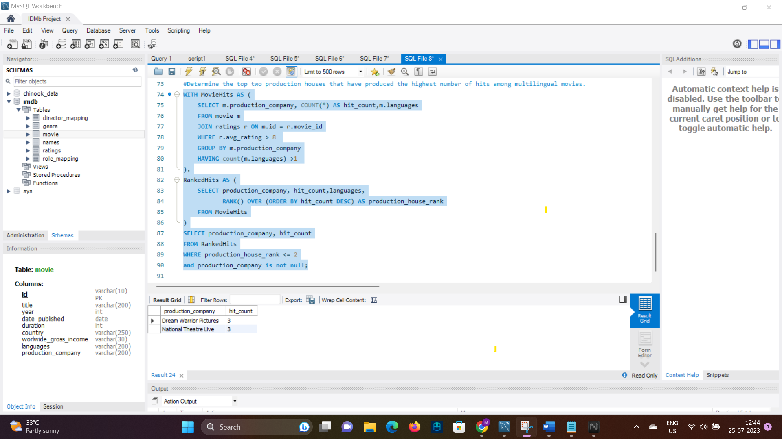

#Identify the top three actresses based on the number of Super Hit movies (average rating > 8) in the drama genre.

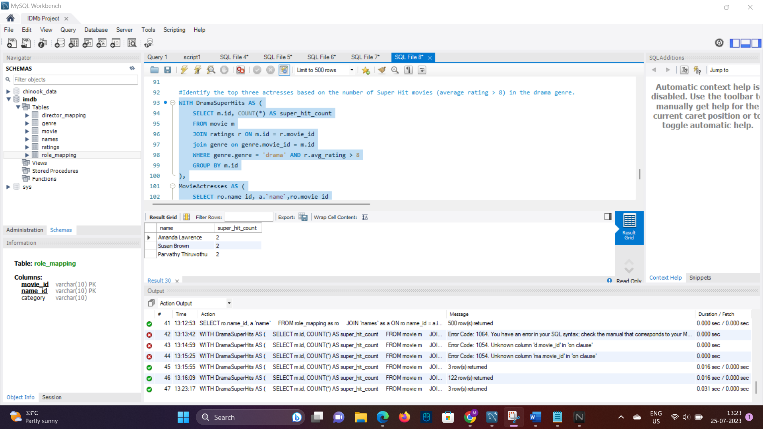

#Retrieve details for the top nine directors based on the number of movies, including average inter-movie duration, ratings, and more.



